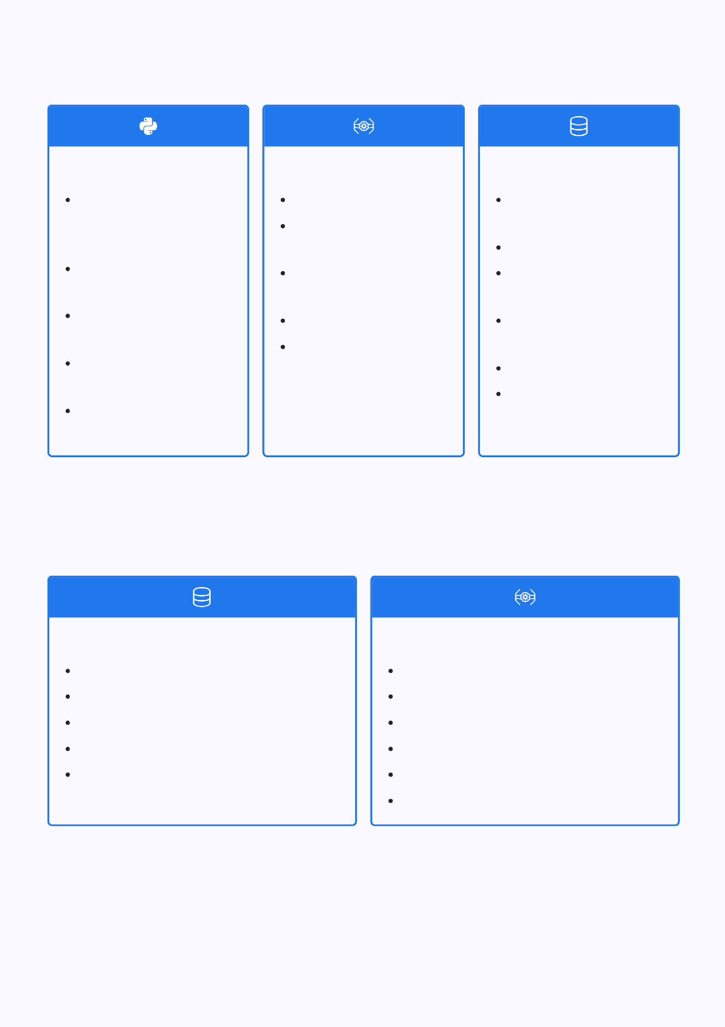
Core Programming Foundations

Python Basics
Python Intro, Comments, Variables, Data Types
Numbers, Casting, Strings, Booleans Operators, Lists, Tuples, Sets, Dictionaries
If-Else, While Loop, For Loops
Functions, Lambda Functions

Python Advanced
Arrays, Classes, Objects
Inheritance, Iterators, Polymorphism
Scope, Modules, Dates, Math
JSON, RegEx, PIP
Try-Except, User Input, File Handling

Pandas
Intro,Series, DataFrames
Read CSV, Read JSON
Analyze Data, Cleaning Data
Cleaning Empty Cells, Wrong Format Removing Duplicates
Pandas Correlations, Pandas Plotting

Database & SQL Mastery

SQL Fundamentals
Intro, Syntax, Select,Select Distinct Where, Order By, And/Or/Not
Insert Into, Null Values, Update, Delete Select Top, Min/Max, Count/Sum/Avg Like, Wildcards, In, Between, Aliases

SQL Advanced
Join,Left Join,Right Join, Self Join Group By, Having, Exists, Case Stored Procedures, Operators Create/Drop DB & Table
Alter DB & Table, Primary/Foreign Key Views

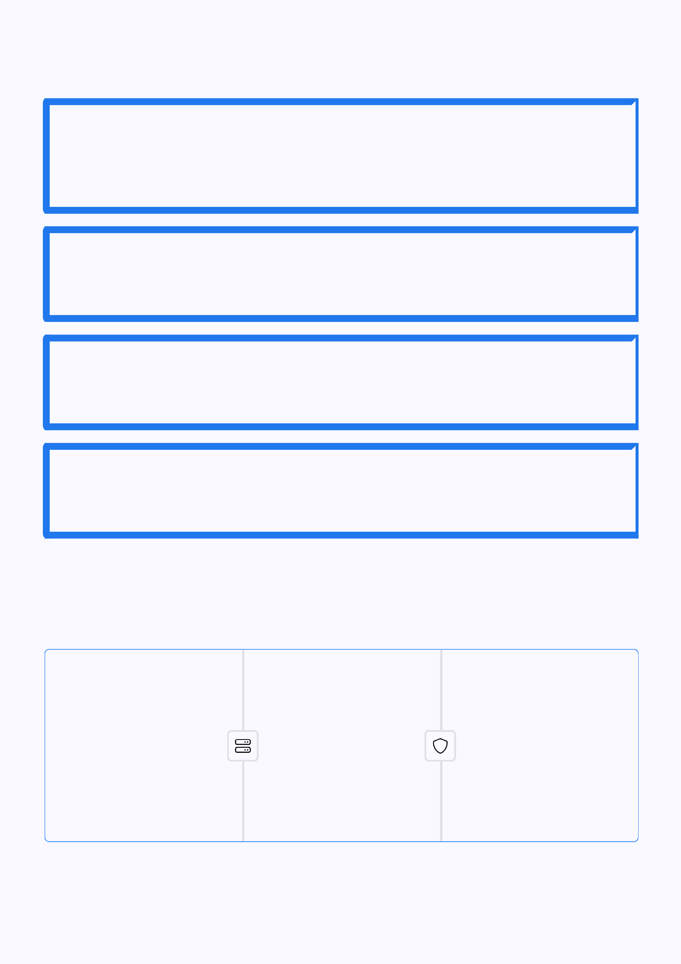
Apache Spark & PySpark Expertise

PySpark Fundamentals
Features, Advantages, Modules and Packages, ClusterManagers, Installation, Architecture, SparkSession, SparkContext, RDD, Parallelize, Repartition/Coalesce, Broadcast Variables, Accumulator

PySpark DataFrame Operations
Create Empty DataFrame,Convert RDD to DF,Convert DF to Pandas, Show(), StructType and StructField, Column Class, Select(), Collect(), WithColumn(), withColumnRenamed()

Advanced DataFrame Methods
where() & filter(), drop() & dropDuplicates(),orderBy() and sort(), groupBy(), join(), union() & unionAll(), unionByName(), UDF, transform(), apply(), map(), flatMap(), foreach()

PySpark SQL Functions
Aggregate Functions, WindowFunctions, Date and Timestamp Functions, JSON Functions, sample() vs sampleBy(), fillna() & fill(), pivot(), partitionBy(), MapType

Cloud Platforms: AWS Fundamentals

AWS Core Services Compute & Management &

Intro, Cloud Computing Benefits, EC2, EC2 Instance Types, EC2 Pricing, EC2 Scaling, EC2 Auto Scaling
Storage
AWS Load Balancing, AWS Lambda, AWS Containers, AWS Availability Zones, AWS S3, AWS RDS, AWS
Redshift
Security
AWS CloudFormation, AWS Elastic Beanstalk, IAM, CloudWatch, AWS Cloud Compliance

Databricks: Unified Analytics Platform


Databricks Basics
Introduction to workspace, clusters, notebooks, DBFS, interactive vs job clusters, connecting to external data sources (S3, ADLS, GCS)

Data Processing
RDD vs DataFramevs Dataset, DataFrame operations, transformations vs actions, joins, aggregations, window functions

Delta Lake
What is Delta Lake, create/read/write Delta tables, ACID transactions, schema enforcement & evolution, time travel

ETL Pipelines
Medallion architecture (Bronze ³ Silver ³ Gold), building batch ETL pipelines, handling SCDs, error handling & retries

Advanced Databricks Features

Data Ingestion & SQL
1
2
3
4
Reading from CSV, JSON, Parquet; writing to storage (managed vs external tables); Autoloader (cloudFiles); SQL queries and dashboards; basic BI integrations

Job Scheduling & Operations
Scheduling notebooks asjobs, alerts & retries, job runs history, merge operations (UPSERTS), update & delete in Delta, optimize & Z-ORDER, VACUUM & data retention

Streaming & Performance
Read/write streaming data, triggers
(microbatch vs continuous), checkpointing, streaming with Delta tables, watermarks & stateful aggregations, partitioning & bucketing, caching & persisting

Advanced Orchestration
Multi-task jobs (DAGs), task dependencies, integrating with Airflow/ADF, parameterized pipelines, Unity Catalog, RBAC, auditing & lineage, Delta Sharing, Delta Live Tables

Microsoft Azure: Cloud Data Engineering

Azure Fundamentals
Cloud computing overview(IaaS, PaaS, SaaS), Azure regions, availability zones, subscriptions, resource groups, Azure Portal, CLI, PowerShell, Azure AD, RBAC

Data Engineering
Azure Data Factory (ADF)intro, Copy Data tool, integration runtime, ADLS Gen2 (hierarchy, security, lifecycle),
Azure Synapse Analytics (dedicated vs
serverless SQL pools)

Governance & Optimization
AzurePurview (data governance & lineage), optimizing ADF pipelines, monitoring with Application Insights, autoscaling Databricks clusters, cost management with pricing calculator

Core Services
Compute:VMs,App Services, Functions; Storage: Blob, Data Lake Gen2, File Storage; Networking: VNets, subnets, NSGs, load balancers; Databases: SQL, Cosmos DB, Synapse
1
2
3
4
5

Advanced Analytics
Azure Databricks (clusters,notebooks,
jobs, Delta Lake integration), HDInsight overview, batch vs streaming architectures, advanced ADF pipelines with branching & parameters

